MENTAL HEALTH DISORDER IDENTIFICATION FROMMOTIVATIONAL CONVERSATIONS
Or
UNVEILING MENTAL HEALTH DISORDERS THROUGH MACHINE LEARNING TECHNIQUE
(Alternate Title)
Abstract
Mental health disorder continues to be a grievous concern plaguing humans worldwide. The identifying various mental disorders is a challenging task. The field of mental health disorders has undergone significant evolution in recent years, spurred by advancements in diagnostic techniques and computational methodologies. This abstract provides a concise overview of the current landscape of mental health disorder classification emerging trends. Machine learning algorithms leverage large datasets to identify complex patterns and improve predictive accuracy, promising to revolutionize the diagnostic process.
This project proposes an innovative approach to mental health disorder classification using machine learning algorithms. The study leverages a diverse dataset comprising various mental health conditions, demographic information, and behavioral patterns. The primary objective is to develop a robust model capable of accurately classifying individuals into different mental health categories based on their unique features. This project focuses on a classification problem to differentiate among MDD, OCC, Anexiety, PTSD, sleeping disorder and Loneliness. In this project are using different Machine Learning Algorithms such as Logistic Regression Algorithm, SVC and Random Forest Algorithm to mental health disorder classification. This project will extend our project to showcase some advanced features so that accuracy will be maintained.
Dataset link: https://www.kaggle.com/code/monicabackes/mental-disorders-model/input
INTRODUCTION
Mental health disorder is considered to be one of the leading causes of disability worldwide with an estimate of about 970 million people suffering from some form of mental or neural disorders.1 On an average, 14.3% of deaths (approximately 8 million) worldwide are identified and attributed to mental disorders each year.2 However, inadequate facilities (as an estimate about 45% of the world’s population lives in a nation where there is fewer than one clinical psychiatrist for every 100 000 mentally ill patients) [1], stigma and prejudice are likely to restrict clinical care to just 15% of individuals affected. Millions of people (also known as support seekers) often resort to seeking emotional or mental health-related support [2] on several text-based peerto- peer support platforms [3] (talklife.co, psychcentral.org) as means to express their emotions and experiences (frequently stigmatized). While peer supporters on these platforms are well-intentioned and inclined in their efforts to assist and
help seekers, they are untrained and frequently uninformed of best practices in therapy, which results in missed opportunities to deliver sound and mutually engaging responses [4], [5]. Traditional methods of training, e.g., in-person counsellor training, are not scalable to the millions of users of online support platforms. Inadequate assistance for counseling and online therapies has prompted the need for the development of human–computer interfaces, namely, virtual agents (VAs), which can detect and respond to end users’ state of mind accordingly. Novel research has been initiated in mental health following the progress in text mining and natural language processing along with the recent developments in messaging services among leading social media companies for developing automated systems in this field [6]–[8]. However, lack of high-quality conversational data in the public domain due to privacy concerns remains a bottleneck toward its study and automation.

LITERATURE SURVEY
Measuring Post Traumatic Stress Disorder in Twitter
Traditional mental health studies rely on information primarily collected through personal contact with a health care professional. Recent work has shown the utility of social media data for studying depression, but there have been limited evaluations of other mental health conditions. We consider post traumatic stress disorder (PTSD), a serious condition that affects millions worldwide, with especially high rates in military veterans. We also present a novel method to obtain a PTSD classifier for social media using simple searches of available Twitter data, a significant reduction in training data cost compared to previous work. We demonstrate its utility by examining differences in language use between PTSD and random individuals, building classifiers to separate these two groups and by detecting elevated rates of PTSD at and around U.S. military bases using our classifiers.

Mental Health Severity Detection from Psychological Forum Data using Domain-Specific Unlabelled Data
Mental health has become a growing concern in the medical field, yet remains difficult to study due to both privacy concerns and the lack of objectively quantifiable measurements (e.g., lab tests, physical exams). Instead, the data that is available for mental health is largely based on subjective accounts of a patient’s experience, and thus typically is expressed exclusively in text. An important source of such data comes from online sources and directly from the patient, including many forms of social media. In this work, we utilize the datasets provided by the CLPsych shared tasks in 2016 and 2017, derived from online forum posts of ReachOut which have been manually classified according to mental health severity. We implemented an automated severity labeling system using different machine and deep learning algorithms. Our approach combines both supervised and semi-supervised embedding methods using corpus from ReachOut (both labeled and unlabelled) and WebMD (unlabelled). Metadata, syntactic, semantic, and embedding features were used to classify the posts into four categories (green, amber, red, and crisis). The developed systems outperformed other state-of-the-art systems developed on the ReachOut dataset and obtained the maximum microaveraged F-scores of 0.86 and 0.80 for CLPsych 2016 and 2017 test datasets, respectively, using the above features.

Predicting Post Severity in Mental Health Forums
We present our approach to predicting the severity of user posts in a mental health forum. This system was developed to compete in the 2016 Computational Linguistics and Clinical Psychology (CLPsych) Shared Task. Our entry employs a meta-classifier which uses a set of of base classifiers constructed from lexical, syntactic and metadata features. These classifiers were generated for both the target posts as well as their contexts, which included both preceding and subsequent posts. The output from these classifiers was used to train a meta-classifier, which outperformed all individual classifiers as well as an ensemble classifier. This meta-classifier was then extended to a Random Forest of meta-classifiers, yielding further improvements in classification accuracy. We achieved competitive results, ranking first among a total of 60 submitted entries in the competition.
Gender and Cross-Cultural Differences in Social Media Disclosures of Mental Illness
Cultural and gender norms shape how mental illness and therapy are perceived. However, there is a paucity of adequate empirical evidence around gender and cultural dimensions of mental illness. In this paper we situate social media as a “lens” to examine these dimensions. We focus on a large dataset of individuals who self-disclose to have an underlying mental health concern on Twitter. Having identified genuine disclosures in this data via semi-supervised learning, we examine differences in their posts, as measured via linguistic attributes and topic models. Our findings reveal significant differences between the content shared by female and male users, and by users from two western and two majority world countries. Males express higher negativity and lower desire for social support, whereas majority world users demonstrate more inhibition in their expression. We discuss the implications of our work in providing insights into the relationship of gender and culture with mental health, and in the design of gender and culture-aware health interventions.

Mental Health Prediction Using Machine Learning
Mental health problems are one of the major concerns of the 21st century in the field of healthcare. One of the major reasons behind this problem is lack of awareness among masses. Our aim with this paper is to help people realize that they might be suffering from some kind of mental problem like depression, anxiety, ptsd, insomnia by making them aware of their symptoms using Machine learning. In order to apply the machine learning algorithms, data was collected from individuals of varied ages, professions, sex and lifestyle through survey form consisting of questions, which are often used by psychologists to understand their patient’s problem in detail.
Predicting Depression via Social Media
Major depression constitutes a serious challenge in personal and public health. Tens of millions of people each year suffer from depression and only a fraction receives adequate treatment. We explore the potential to use social media to detect and diagnose major depressive disorder in individuals. We first employ crowdsourcing to compile a set of Twitter users who report being diagnosed with clinical depression, based on a standard psychometric instrument. Through their social media postings over a year preceding the onset of depression, we measure behavioral attributes relating to social engagement, emotion, language and linguistic styles, ego network, and mentions of antidepressant medications. We leverage these behavioral cues, to build a statistical classifier that provides estimates of the risk of depression, before the reported onset. We find that social media contains useful signals for characterizing the onset of depression in individuals, as measured through decrease in social activity, raised negative affect, highly clustered egonetworks, heightened relational and medicinal concerns, and greater expression of religious involvement. We believe our findings and methods may be useful in developing tools for identifying the onset of major depression, for use by healthcare agencies; or on behalf of individuals, enabling those suffering from depression to be more proactive about their mental health.

Deep Learning for Depression Detection of Twitter Users
Mental illness detection in social media can be considered a complex task, mainly due to
the complicated nature of mental disorders. In recent years, this research area has started to evolve with the continuous increase in popularity of social media platforms that became an integral part of people’s life. This close relationship between social media platforms and their users has made these platforms to reflect the users’ personal life on many levels. In such an environment, researchers are presented with a wealth of information regarding one’s life. In addition to the level of complexity in identifying mental illnesses through social media platforms, adopting supervised machine learning approaches such as deep neural networks have not been widely accepted due to the difficulties in obtaining sufficient amounts of annotated training data. Due to these reasons, we try to identify the most effective deep neural network architecture among a few of selected architectures that were successfully used in natural language processing tasks. The chosen architectures are used to detect users with signs of mental illnesses (depression in our case) given limited unstructured text data extracted from the Twitter social media platform.

EXISTING SYSTEM
Existing datasets on mental health had limitations in the context of our proposed task. In existing the research work of LSTM and BILSTM neural network algorithms used for mental health disorder. There are two major parameters that are involved in understanding the suitability of the respective methodologies and they are - the time taken to execute the prediction process and the accuracy of the classification result is very low.

Drawback
- Accuracy of the predictive result is very low.
- Existing dataset consisting of dyadic conversations.
- Existing an analysis of the dataset revealed that the users showing their feelings and expressing sufferings embodied their overall sentiment as well to some extent.

PROPOSED SYSTEM
In proposed system, three Machine learning algorithms used in mental health disorder classification are Logistic Regression Algorithm, SVC and Random Forest Algorithm concluding that these algorithms can achieve high accuracy in classification mental health disorder. In this proposed dataset includes various symptoms for a range of mental disorders, such as ADHD, OCD, PTSD, and more. As we know, identifying these disorders is crucial for improving the quality of life for many individuals.

Advantages
- Machine learning algorithms can analyze a large amount of data to assist medical professionals in making more informed decisions cost-effectively.
- Machine Learning algorithms allowed us to analyze clinical data, draw relationships between diagnostic variables, design the predictive model, and test it against the new case.
- Finally, the model we built to mental health disorder can save enormous medical bills, improve diagnosis capability on large scale, and most importantly save live
- It can help analyze progress on normal development.

MODULE DESCRIPTION

Data Preparation & Cleaning:
The data has been imported from kaggle website. The website provides with a variety of data and the data used for the project is an mental disorder. The data included various attributes such as ADHD, OCD, PTSD, and more which will work as the label for the project. The data was in structured format and was stores in a csv file format. The data was imported using pandas library. The presence of missing, incomplete, or corrupted data leads to wrong results while performing any functions such as count, average, mean etc. These inconsistencies must be removed before doing any analysis on data. The data included some ambiguous values which were needed to be removed.

Feature Selection:
Use techniques like correlation analysis to select the most relevant features that affect mental disorder. Removing irrelevant or highly correlated features can improve the accuracy of your model.

Training:
Once training data is in a suitable form to feed to the model, the training and testing phase of the model can proceed. During the training phase, the primary concern is the model selection. This involves choosing the best modeling approach for the task, or the best parameter settings for a given model. In fact, the term model selection often refers to both of these processes, as, in many cases, various models were tried first and best performing model (with the best performing parameter settings for each model) was selected.

Model Selection:
Choose appropriate regression algorithms for your forecasting task. Common models include Logistic Regression Algorithm, SVC and Random Forest Algorithm,. You might need to experiment with multiple algorithms to determine which one performs best on your dataset.

Prediction:
The model was used to predict the mental disorder that would be spent on their health. The model used the relation between the features and the label to predict the disorder. Accuracy defines the degree of correctness of the predicted value of the disorder. The model predicted the accuracy of model by using different algorithms, different features and different train test split size. The size of the data used for training of data has a huge impact on the accuracy of data. The larger the train size, the better is the accuracy.

Hardware Specification
Processor : i3
Hard Disk : 500 GB
RAM : 8GB RAM
Video : LED

Software Specification
Operating system: Windows 10
Front end: PYTHON

SYSTEM ENVIRONMENT
LANGUAGE FEATURES
Python is an interpreter, object-oriented, high-level programming language with dynamic semantics. Its high-level built in data structures, combined with dynamic typing and dynamic binding, make it very attractive for Rapid Application Development, as well as for use as a scripting or glue language to connect existing components together. Python's simple, easy to learn syntax emphasizes readability and therefore reduces the cost of program maintenance. Python supports modules and packages, which encourages program modularity and code reuse. The Python interpreter and the extensive standard library are available in source or binary form without charge for all major platforms, and can be freely distributed.
Often, programmers fall in love with Python because of the increased productivity it provides. Since there is no compilation step, the edit-test-debug cycle is incredibly fast. Debugging Python programs is easy: a bug or bad input will never cause a segmentation fault. Instead, when the interpreter discovers an error, it raises an exception. When the program doesn't catch the exception, the interpreter prints a stack trace. A source level debugger allows inspection of local and global variables, evaluation of arbitrary expressions, setting breakpoints, stepping through the code a line at a time, and so on. The debugger is written in Python itself, testifying to Python's introspective power. On the other hand, often the quickest way to debug a program is to add a few print statements to the source: the fast edit-test-debug cycle makes this simple approach very effective.
Statements and control flow

The assignment statement (token '=', the equals sign). This operates differently than in traditional imperative programming languages, and this fundamental mechanism (including the nature of Python's version of variables) illuminates many other features of the language. Assignment in C, e.g., x = 2, translates to "typed variable name x receives a copy of numeric value 2". The (right-hand) value is copied into an allocated storage location for which the (left-hand) variable name is the symbolic address. The memory allocated to the variable is large enough (potentially quite large) for the declared type. In the simplest case of Python assignment, using the same example, x = 2, translates to "(generic) name x receives a reference to a separate, dynamically allocated object of numeric (int) type of value 2." This is termed binding the name to the object. Since the name's storage location doesn't contain the indicated value, it is improper to call it a variable. Names may be subsequently rebound at any time to objects of greatly varying types, including strings, procedures, complex objects with data and methods, etc. Successive assignments of a common value to multiple names, e.g., x = 2; y = 2; z = 2 result in allocating storage to (at most) three names and one numeric object, to which all three names are bound. Since a name is a generic reference holder it is unreasonable to associate a fixed data type with it. However at a given time a name will be bound to some object, which will have a type; thus there is dynamic typing.

The if statement, which conditionally executes a block of code, along with else and elif (a contraction of else-if). The for statement, which iterates over an iterable object, capturing each element to a local variable for use by the attached block. The while statement, which executes a block of code as long as its condition is true.

The try statement, which allows exceptions raised in its attached code block to be caught and handled by except clauses; it also ensures that clean-up code in a finally block will always be run regardless of how the block exits. The class statement, which executes a block of code and attaches its local namespace to a class, for use in object-oriented programming. The def statement, which defines a function or method. The with statement (from Python 2.5), which encloses a code block within a context manager (for example, acquiring a lock before the block of code is run and releasing the lock afterwards, or opening a file and then closing it), allowing Resource Acquisition Is Initialization (RAII)-like behavior. The pass statement, which serves as a NOP. It is syntactically needed to create an empty code block. The assert statement, used during debugging to check for conditions that ought to apply. The yield statement, which returns a value from a generator function. From Python 2.5, yield is also an operator. This form is used to implement coroutines.

The import statement, which is used to import modules whose functions or variables can be used in the current program. There are four ways of using import: import <module name> or from <module name> import * or import numpy as np or from numpy import pi as Pie. The print statement was changed to the print() function in Python 3. Python does not support tail call optimization or first-class continuations, and, according to Guido van Rossum, it never will. However, better support for coroutine-like functionality is provided in 2.5, by extending Python's generators. Before 2.5, generators were lazy iterators; information was passed unidirectionally out of the generator. From Python 2.5, it is possible to pass information back into a generator function, and from Python 3.3, the information can be passed through multiple stack levels.

Tkinter
Tkinter is a Python binding to the Tk GUI toolkit. It is the standard Python interface to the Tk GUI toolkit,[1] and is Python's de facto standard GUI.[2] Tkinter is included with the standard Microsoft Windows and Mac OS X install of Python.
The name Tkinter comes from Tk interface. Tkinter was written by Fredrik Lundh.
As with most other modern Tk bindings, Tkinter is implemented as a Python wrapper around a complete Tcl interpreter embedded in the Python interpreter. Tkinter calls are translated into Tcl commands which are fed to this embedded interpreter, thus making it possible to mix Python and Tcl in a single application.
Python 2.7 and Python 3.1 incorporate the "themed Tk" ("ttk") functionality of Tk 8.5. This allows Tk widgets to be easily themed to look like the native desktop environment in which the application is running, thereby addressing a long-standing criticism of Tk (and hence of Tkinter).
tkinter provides us with a variety of common GUI elements which we can use to build our interface – such as buttons, menus and various kinds of entry fields and display areas. We call these elements widgets. We are going to construct a tree of widgets for our GUI – each widget will have a parent widget, all the way up to the root window of our application. For example, a button or a text field needs to be inside some kind of containing window.
The widget classes provide us with a lot of default functionality. They have methods for configuring the GUI’s appearance – for example, arranging the elements according to some kind of layout – and for handling various kinds of user-driven events. Once we have constructed the backbone of our GUI, we will need to customise it by integrating it with our internal application class.
Window
This term has different meanings in different contexts, but in general it refers to a rectangular area somewhere on the user's display screen.
Top Level Window
A window that exists independently on the screen. It will be decorated with the standard frame and controls for the desktop manager. It can be moved around the desktop, and can usually be resized.
Widget
The generic term for any of the building blocks that make up an application in a graphical user interface. Examples of widgets: buttons, radiobuttons, text fields, frames, and text labels.
Frame
In Tkinter, the Frame widget is the basic unit of organization for complex layouts. A frame is a rectangular area that can contain other widgets.
Child and parent
When any widget is created, a parent-child relationship is created. For example, if you place a text label inside a frame, the frame is the parent of the label.
It have often been asked: "Is there no Tk for Python?" or "Is Tkinter the same as Tk?" Of course, there is Tk for Python. Without Tk Python would be less attractive to many users. Tk is called Tkinter in Python, or to be precise, Tkinter is the Python interface for Tk. Tkinter is an acronym for "Tk interface".
Tk was developed as a GUI extension for the Tcl scripting language by John Ousterhout. The first release was in 1991. Tk proved as extremely successful in the 1990's, because it is easier to learn and to use than other toolkits. So it is no wonder that many programmers wanted to use Tk independently of Tcl. That's why bindings for lots of other programming languages have been developed, including Perl, Ada (called TASH), Python (called Tkinter), Ruby, and Common Lisp.
Tk provides the following widgets:
- button
- canvas
- checkbutton
- combobox
- entry
- frame
- label
- labelframe
- listbox
- menu
- menubutton
- message
- notebook
- tk_optionMenu
- panedwindow
- progressbar
- radiobutton
- scale
- scrollbar
- separator
- sizegrip
- spinbox
- text
- treeview
It provides the following top-level windows:
- tk_chooseColor - pops up a dialog box for the user to select a color.
- tk_chooseDirectory - pops up a dialog box for the user to select a directory.
- tk_dialog - creates a modal dialog and waits for a response.
- tk_getOpenFile - pops up a dialog box for the user to select a file to open.
- tk_getSaveFile - pops up a dialog box for the user to select a file to save.
- tk_messageBox - pops up a message window and waits for a user response.
- tk_popup - posts a popup menu.
- toplevel - creates and manipulates toplevel widgets.
Tk also provides three geometry managers:
- place - which positions widgets at absolute locations
- grid - which arranges widgets in a grid
- pack - which packs widgets into a cavity

Distutils Basics and Design Flaws
Distutils contains commands, each of which is a class with a run method that can be called with some options. Distutils also provides a Distribution class that contains global values every command can look at.
To use Distutils, a developer adds a single Python module to a project, conventionally called setup.py. This module contains a call to Distutils' main entry point: the setup function. This function can take many options, which are held by a Distribution instance and used by commands. Here's an example that defines a few standard options like the name and version of the project, and a list of modules it contains:
from distutils.core import setup

setup(name='MyProject', version='1.0', py_modules=['mycode.py'])
This module can then be used to run Distutils commands like sdist, which creates a source distribution in an archive and places it in a dist directory:
$ python setup.py sdist
Using the same script, you can install the project using the install command:
$ python setup.py install
Distutils provides other commands such as:
- upload to upload a distribution into an online repository.
- register to register the metadata of a project in an online repository without necessary uploading a distribution,
- bdist to creates a binary distribution, and
- bdist_msi to create a .msi file for Windows.
It will also let you get information about the project via other command line options.
So installing a project or getting information about it is always done by invoking Distutils through this file. For example, to find out the name of the project:
$ python setup.py --name
MyProject
setup.py is therefore how everyone interacts with the project, whether to build, package, publish, or install it. The developer describes the content of his project through options passed to a function, and uses that file for all his packaging tasks. The file is also used by installers to install the project on a target system.
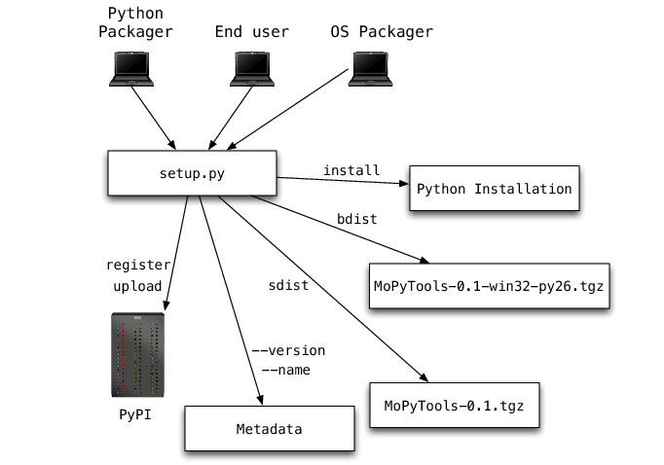
Figure 14.1: Setup

What is Python?
Python is a popular programming language. It was created in 1991 by Guido van Rossum.
It is used for:
- web development (server-side),
- software development,
- mathematics,
- system scripting.

Introduction
Python is a general-purpose interpreted, interactive, object-oriented, and high-level programming language. It was created by Guido van Rossum during 1985- 1990. Like Perl, Python source code is also available under the GNU General Public License (GPL). This tutorial gives enough understanding on Python programming language.

Python is a high-level, interpreted, interactive and object-oriented scripting language. Python is designed to be highly readable. It uses English keywords frequently where as other languages use punctuation, and it has fewer syntactical constructions than other languages.

- Python is Interpreted − Python is processed at runtime by the interpreter. You do not need to compile your program before executing it. This is similar to PERL and PHP.
- Python is Interactive − You can actually sit at a Python prompt and interact with the interpreter directly to write your programs.
- Python is Object-Oriented − Python supports Object-Oriented style or technique of programming that encapsulates code within objects.
- Python is a Beginner's Language − Python is a great language for the beginner-level programmers and supports the development of a wide range of applications from simple text processing to www browsers to games.

History of Python
Python was developed by Guido van Rossum in the late eighties and early nineties at the National Research Institute for Mathematics and Computer Science in the Netherlands.
Python is derived from many other languages, including ABC, Modula-3, C, C++, Algol-68, SmallTalk, and Unix shell and other scripting languages.
Python is copyrighted. Like Perl, Python source code is now available under the GNU General Public License (GPL).
Python is now maintained by a core development team at the institute, although Guido van Rossum still holds a vital role in directing its progress.

Python Features

Python's features include −
- Easy-to-learn − Python has few keywords, simple structure, and a clearly defined syntax. This allows the student to pick up the language quickly.
- Easy-to-read − Python code is more clearly defined and visible to the eyes.
- Easy-to-maintain − Python's source code is fairly easy-to-maintain.
- A broad standard library − Python's bulk of the library is very portable and cross-platform compatible on UNIX, Windows, and Macintosh.
- Interactive Mode − Python has support for an interactive mode which allows interactive testing and debugging of snippets of code.
- Portable − Python can run on a wide variety of hardware platforms and has the same interface on all platforms.
- Extendable − You can add low-level modules to the Python interpreter. These modules enable programmers to add to or customize their tools to be more efficient.
- Databases − Python provides interfaces to all major commercial databases.
- GUI Programming − Python supports GUI applications that can be created and ported to many system calls, libraries and windows systems, such as Windows MFC, Macintosh, and the X Window system of Unix.
- Scalable − Python provides a better structure and support for large programs than shell scripting.
- Apart from the above-mentioned features, Python has a big list of good features, few are listed below −
- It supports functional and structured programming methods as well as OOP.
- It can be used as a scripting language or can be compiled to byte-code for building large applications.
- It provides very high-level dynamic data types and supports dynamic type checking.
- It supports automatic garbage collection.
- It can be easily integrated with C, C++, COM, ActiveX, CORBA, and Java.

Local Environment Setup
Open a terminal window and type "python" to find out if it is already installed and which version is installed.
- Unix (Solaris, Linux, FreeBSD, AIX, HP/UX, SunOS, IRIX, etc.)
- Win 9x/NT/2000
- Macintosh (Intel, PPC, 68K)
- OS/2
- DOS (multiple versions)
- PalmOS
- Nokia mobile phones
- Windows CE
- Acorn/RISC OS
- BeOS
- Amiga
- VMS/OpenVMS
- QNX
- VxWorks
- Psion
- Python has also been ported to the Java and .NET virtual machines.

Integrated Development Environment
You can run Python from a Graphical User Interface (GUI) environment as well, if you have a GUI application on your system that supports Python.
- Unix − IDLE is the very first Unix IDE for Python.
- Windows − PythonWin is the first Windows interface for Python and is an IDE with a GUI.
- Macintosh − The Macintosh version of Python along with the IDLE IDE is available from the main website, downloadable as either MacBinary or BinHex'd files.
If you are not able to set up the environment properly, then you can take help from your system admin. Make sure the Python environment is properly set up and working perfectly fine.

Testing:
Introduction
The most important phase in system development life cycle is system testing. The number and nature of errors in a newly designed system depends on the system specifications and the time frame given for the design.
A newly designed system should have all the subsystems working together, but in reality each subsystems work independently. During this phase, all the subsystems are gathered into one pool and tested to determine whether it meets the user requirements.
Testing is done at two level -Testing of individual modules and testing the entire system. During the system testing, the system is used experimentally to ensure that the software will run according to the specifications and in the way the user expects. Each test case is designed with the intent of finding errors in the way the system will process it.
Testing plays a very critical role in determining the reliability and efficiency of software and hence is a very important stage in software development. Software testing is done at different levels. They are the unit testing and system testing which comprises of integration testing and acceptance testing.
TYPES OF TESTING
Unit Testing
This is the first level of testing. The different modules are tested against the specifications produced during the integration. This is done to test the internal logic of each module. Those resulting from the interaction between modules are initially avoided. The input received and output generated is also tested to see whether it falls in the expected range of values. Unit testing is performed from the bottom up, starting with the smallest and lowest modules and proceeding one at a time.

The units in a system are the modules and routines that are assembled and integrated to perform a specific function. The programs are tested for correctness of logic applied and detection of errors in coding. Each of the modules was tested and errors are rectified. They were then found to function properly.
Integration Testing
In integration testing, the tested modules are combined into sub-systems, which are then tested. The goal of integration testing to check whether the modules can be integrated properly emphasizing on the interfaces between modules. The different modules were linked together and integration testing done on them.
Validation Testing
The objective of the validation test is to tell the user about the validity and reliability of the system. It verifies whether the system operates as specified and the integrity of important data is maintained. User motivation is very important for the successful performance of the system.
All the modules were tested individually using both test data and live data. After each module was ascertained that it was working correctly and it had been "integrated" with the system. Again the system was tested as a whole. We hold the system tested with different types of users. The System Design, Data Flow Diagrams, procedures etc. were well documented so that the system can be easily maintained and upgraded by any computer professional at a later
System Testing
The integration of each module in the system is checked during this level of testing. The objective of system testing is to check if the software meets its requirements. System testing is done to uncover errors that were not found in earlier tests. This includes forced system failures and validation of total system as the user in the operational environment implements it. Under this testing, low volumes of transactions are generally based on live data. This volume is increased until the maximum level for each transactions type is reached. The total system is also tested for recovery after various major failures to ensure that no data are lost during the breakdown.

FEASIBILITY STUDY

The feasibility of the project is analyzed in this phase and business proposal is put forth with a very general plan for the project and some cost estimates. During system analysis the feasibility study of the proposed system is to be carried out. This is to ensure that the proposed system is not a burden to the company. For feasibility analysis, some understanding of the major requirements for the system is essential.
The feasibility study investigates the problem and the information needs of the stakeholders. It seeks to determine the resources required to provide an information systems solution, the cost and benefits of such a solution, and the feasibility of such a solution. The analyst conducting the study gathers information using a variety of methods, the most popular of which are:
- Interviewing users, employees, managers, and customers.
- Developing and administering questionnaires to interested stakeholders, such as potential users of the information system.
- Observing or monitoring users of the current system to determine their needs as well as their satisfaction and dissatisfaction with the current system.
- Collecting, examining, and analyzing documents, reports, layouts, procedures, manuals, and any other documentation relating to the operations of the current system.
- Modelling, observing, and simulating the work activities of the current system.
The goal of the feasibility study is to consider alternative information systems solutions, evaluate their feasibility, and propose the alternative most suitable to the organization. The feasibility of a proposed solution is evaluated in terms of its components. These components are:
- ECONOMICAL FEASIBILITY
- TECHNICAL FEASIBILITY
- SOCIAL FEASIBILITY
- OPERATIONAL FEASIBILITY

ECONOMICAL FEASIBILITY
This study is carried out to check the economic impact that the system will have on the organization. The amount of fund that the company can pour into the research and development of the system is limited. The expenditures must be justified. Thus the developed system as well within the budget and this was achieved because most of the technologies used are freely available. Only the customized products had to be purchased.

TECHNICAL FEASIBILITY
This study is carried out to check the technical feasibility, that is, the technical requirements of the system. Any system developed must not have a high demand on the available technical resources. This will lead to high demands on the available technical resources. This will lead to high demands being placed on the client. The developed system must have a modest requirement, as only minimal or null changes are required for implementing this system.

SOCIAL FEASIBILITY
The aspect of study is to check the level of acceptance of the system by the user. This includes the process of training the user to use the system efficiently. The user must not feel threatened by the system, instead must accept it as a necessity.

The level of acceptance by the users solely depends on the methods that are employed to educate the user about the system and to make him familiar with it. His level of confidence must be raised so that he is also able to make some constructive criticism, which is welcomed, as he is the final user of the system.

OPERATIONAL FEASIBILITY
The ability, desire, and willingness of the stakeholders to use, support, and operate the proposed computer information system. The stakeholders include management, employees, customers, and suppliers. The stakeholders are interested in systems that are easy to operate, make few, if any, errors, produce the desired information, and fall within the objectives of the organization.

IMPLEMENTATION
Implementation is the most crucial stage in achieving a successful system and giving the user’s confidence that the new system is effective and workable. Implementation of this project refers to the installation of the package in its real environment to the full satisfaction of the users and operations of the system.
Testing is done individually at the time of development using the data and verification is done the way specified in the program specification. In short, implementation constitutes all activities that are required to put an already tested and completed package into operation. The success of any information system lies in its successful implementation.
System Implementation is the stage in the project where the theoretical design is turned into a working system. The most critical stage is achieving a successful system and in giving confidence on the new system for the user that it will work efficiently and effectively. The existing system was long time process.
The project execution was checked with live environment and the user requirements are satisfied. Proper implementation is essential to provide a reliable system to meet the organization requirements.

SYSTEM DESIGN AND DEVELOPMENT

INPUT DESIGN

Input design is the process of converting user-originated inputs to a computer-based format. Input design is one of the most expensive phases of the operation of computerized system and is often the major problem of a system. In the project, the input design is made in window form in python with ML methods. For example, in the user enter the disorder values in the form. The dataset is composed of survey results of people who filled out an app form. There are labels portraying whether the person received a diagnosis of mental disorder.

OUTPUT DESIGN

Output design generally refers to the results and information that are generated by ML model. Provide a probability score for the prediction. This indicates the model's level of certainty regarding the classification. Performance metrics are used to assess the effectiveness of the model and its ability to accurately predict outcomes. In this context, it is important to evaluate the model's accuracy, precision, recall, and F1-score to ensure the model is performing well.

FILE DESIGN
At the highest level a ﬁle system is a way to organize, store, retrieve, and manage information on a permanent storage medium such as a disk. File systems manage permanent storage and form an integral part of all operating systems. There are many different approaches to the task of managing permanent storage. At one end of the spectrum are simple ﬁle systems that impose enough restrictions to inconvenience users and make using the ﬁle system difficult. At the other end of the spectrum are persistent object stores and object-oriented databases that abstract the whole notion of permanent storage so that the user and programmer never even need to be aware of it. The problem of storing, retrieving, and manipulating information on a computer is of a general-enough nature that there are many solutions to the problem.
The primary functionality that all ﬁle systems must provide is a way to store a named piece of data and to later retrieve that data using the name given to it. We often refer to a named piece of data as a ﬁle. A ﬁle provides only the most basic level of functionality in a ﬁle system. A ﬁle is where a program stores data permanently. In its simplest form a ﬁle stores a single piece of information. A piece of information can be a bit of text (e.g., a letter, program source code, etc.), a graphic image, a database, or any collection of bytes a user wishes to store permanently. The size of data stored may range from only a few bytes to the entire capacity of a volume. A ﬁle system should be able to hold a large number of ﬁles, where “large” ranges from tens of thousands to millions.

The name of a ﬁle is metadata because it is a piece of information about the ﬁle that is not in the stream of bytes that make up the ﬁle. There are several other pieces of metadata about a ﬁle as well—for example, the owner, security access controls, date of last modiﬁcation, creation time, and size. The ﬁle system needs a place to store this metadata in addition to storing the ﬁle contents.

SYSTEM DEVELOPEMENT
A Systems Development Life Cycle (SDLC) adheres to important phases that are essential for developers, such as planning, analysis, design, and implementation, and are explained in the section below. A number of system development life cycle (SDLC) models have been created: waterfall, fountain, spiral, build and fix, rapid prototyping, incremental, and synchronize and stabilize. The oldest of these, and the best known, is the waterfall model: a sequence of stages in which the output of each stage becomes the input for the next.
The waterfall model is a popular version of the systems development life cycle model for software engineering. Often considered the classic approach to the systems development life cycle, the waterfall model describes a development method that is linear and sequential. Waterfall development has distinct goals for each phase of development. Imagine a waterfall on the cliff of a steep mountain. Once the water has flowed over the edge of the cliff and has begun its journey down the side of the mountain, it cannot turn back. It is the same with waterfall development. Once a phase of development is completed, the development proceeds to the next phase and there is no turning back.
The advantage of waterfall development is that it allows for departmentalization and managerial control. A schedule can be set with deadlines for each stage of development and a product can proceed through the development process like a car in a carwash, and theoretically, be delivered on time. Development moves from concept, through design, implementation, testing, installation, troubleshooting, and ends up at operation and maintenance. Each phase of development proceeds in strict order, without any overlapping.

Flow Diagram

Collect Data
Data Preparation & Cleaning

Feature Selection
Training
Model Selection
Prediction

RESULT AND DISCUSSION

The results of the mental health disorder using machine learning (ML) show promising accuracy levels. The analysis reveals that the implemented ML algorithms, such as Logistic regression, random forest and SVC, perform well in mental disorder. Comparing the performance of these algorithms, Logistic regression, random forest and SVC stand out as efficient predictors of disorder. The model shows potential in accurately predicting. The web-based application developed for mental health disorder prediction is user-friendly and can facilitate early intervention and improved outcomes for individuals with mental health disorder.

ML Algorithm | Accuracy
Random Forest | 99%
Logistic Regression | 97%
SVC | 77%

CONCLUSION
In our research, we harnessed the capabilities of Random Forest, a robust machine learning technique, to tackle the vital task of categorizing and predicting mental disorders. The Kaggle dataset, containing comprehensive information on mental health conditions, served as the foundational source for training and evaluating our models. Random Forest exhibited several merits in this context, including robustness, interpretability, and the ability to handle intricate, non-linear associations within the data. Throughout our experiments, Random Forest consistently demonstrated high accuracy in effectively classifying individuals into distinct mental health categories. The algorithm's resilience was evident in its adept handling of diverse datasets characterized by varying features and complexities.
In contrast to existing methods, our suggested Random Forest (RF) approach surpassed them in terms of accuracy (98.95%), precision (99.04%), and F-measure (98.94%). The interpretability of the Random Forest proved pivotal in identifying key factors contributing to the classification of mental disorders. This newfound knowledge serves as a valuable asset for mental health providers, enabling targeted intervention and personalized treatment planning. It is essential to acknowledge that the success of the Random Forest model relies on the quality and representativeness of the training data. Ensuring the model's ability to generalize necessitates addressing biases within the dataset and promoting diversity.
The utilization of Random Forest for the classification and prediction of mental disorders holds significant promise for advancing personalized mental healthcare. While implementing this approach may pose challenges, the potential benefits, such as early intervention, tailored treatment, and improved patient outcomes, underscore the value of integrating data science into mental health care.
FUTURE WORK
Identifying mental health disorders using machine learning is a rapidly evolving field. While significant progress has been made, there is still substantial room for improvement and innovation. Collecting data over extended periods can help capture the progression of mental health disorders and improve predictive accuracy. In future work Utilizing advanced deep learning techniques, including transformers and attention mechanisms, can enhance the ability to capture complex patterns in mental health data. Developing models that provide interpretable and transparent predictions can help in understanding the underlying factors contributing to mental health disorders. By addressing these areas, future research can significantly advance the field of mental health disorder identification using machine learning, leading to more effective, personalized, and equitable mental health care.

REFERENCES
[1] A. P. Association. Global Mental Health. Accessed: Feb. 24, 2022. [Online]. Available: https://www.psychiatry.org/ psychiatrists/international/global-mental-health
[2] G. Eysenbach, J. Powell, M. Englesakis, C. Rizo, and A. Stern, “Health related virtual communities and electronic support groups: Systematic review of the effects of online peer to peer interactions,” BMJ, vol. 328, no. 7449, p. 1166, May 2004.
[3] M. D. Choudhury and S. De, “Mental health discourse on reddit: Selfdisclosure, social support, and anonymity,” in Proc. 8th Int. AAAI Conf. Weblogs Social Media, 2014, pp. 1–10.
[4] M. Domínguez and L. Sapiña, “Pediatric cancer and the internet: Exploring the gap in doctor-parents communication,” J. Cancer Educ., vol. 30, no. 1, pp. 145–151, Mar. 2015.
[5] E. A. Gage-Bouchard, S. LaValley, M. Warunek, L. K. Beaupin, and M. Mollica, “Is cancer information exchanged on social media scientifically accurate?” J. Cancer Educ., vol. 33, no. 6, pp. 1328–1332, Dec. 2018.
[6] K. K. Fitzpatrick, A. Darcy, and M. Vierhile, “Delivering cognitive behavior therapy to young adults with symptoms of depression and anxiety using a fully automated conversational agent (Woebot): A randomized controlled trial,” JMIR Mental Health, vol. 4, no. 2, p. e19, Jun. 2017.
[7] B. Inkster, S. Sarda, and V. Subramanian, “An empathy-driven, conversational artificial intelligence agent (Wysa) for digital mental wellbeing: Real-world data evaluation mixed-methods study,” JMIR mHealth uHealth, vol. 6, no. 11, Nov. 2018, Art. no. e12106.
[8] S. Anand, D. Bein, J. Andro-Vasko, and W. Bein, “Speakout, a web app for online therapy and web counseling,” in Proc. 17th Int. Conf. Inf. Technol. New Generat. (ITNG). Springer, 2020, pp. 371–377.
[9] M. Dowling and D. Rickwood, “Exploring hope and expectations in the youth mental health online counselling environment,” Comput. Hum. Behav., vol. 55, pp. 62–68, Feb. 2016.
[10] M. Gaur et al., “‘Let me tell you about your mental health!’: Contextualized classification of reddit posts to DSM-5 for web-based intervention,” in Proc. 27th ACM Int. Conf. Inf. Knowl. Manage., (CIKM), A. Cuzzocrea et al., Eds. Turin, Italy: ACM, Oct. 2018, pp. 753–762, doi: 10.1145/3269206.3271732.

Screens

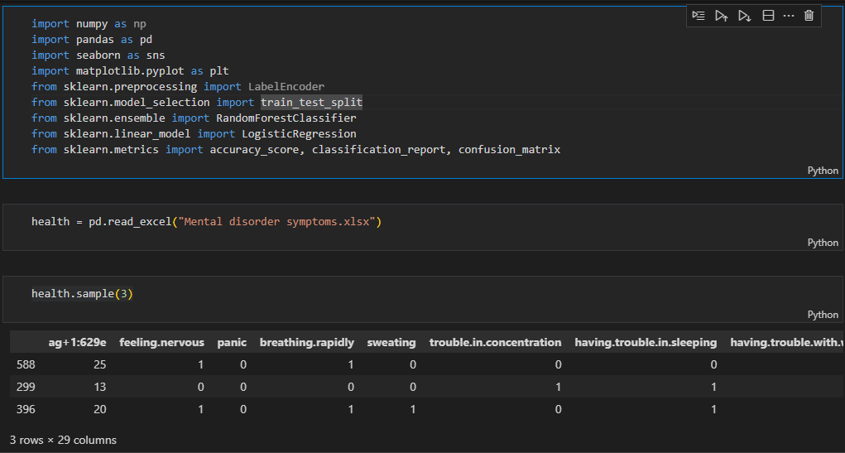

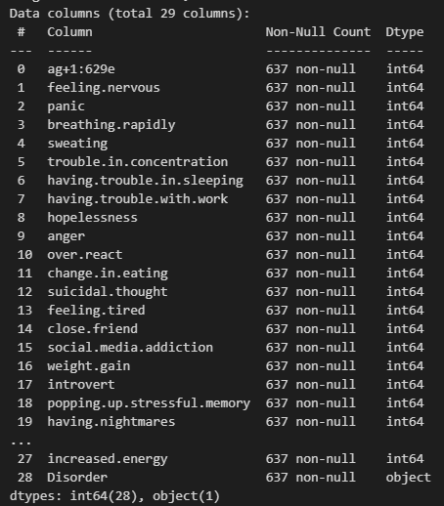

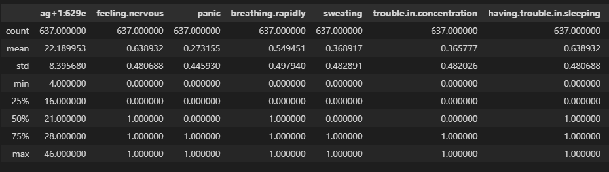

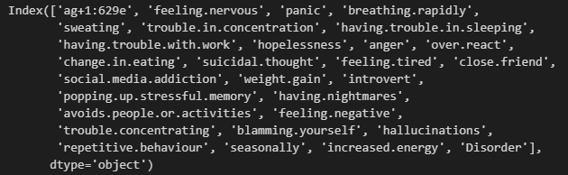

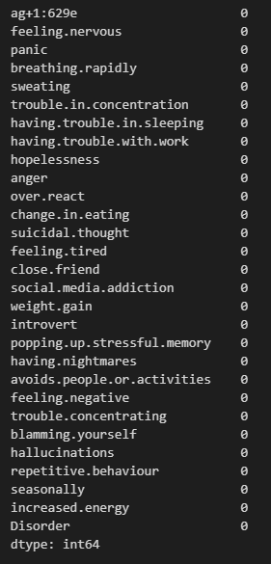

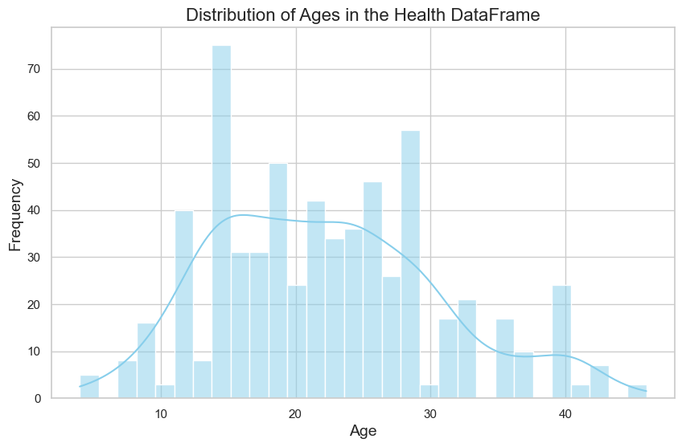

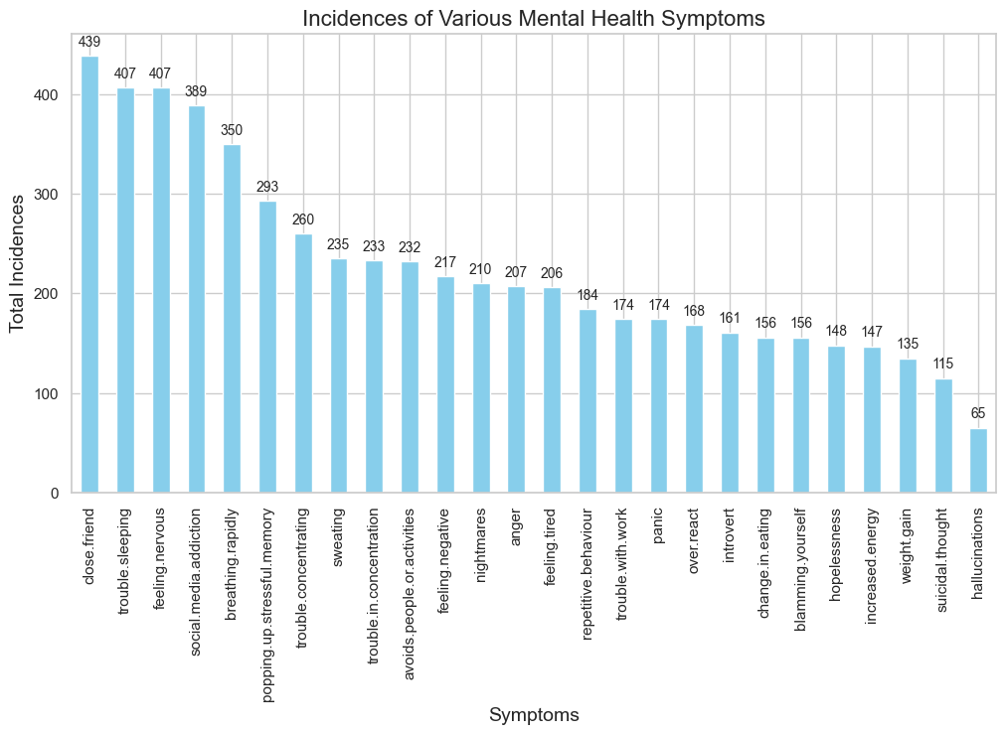

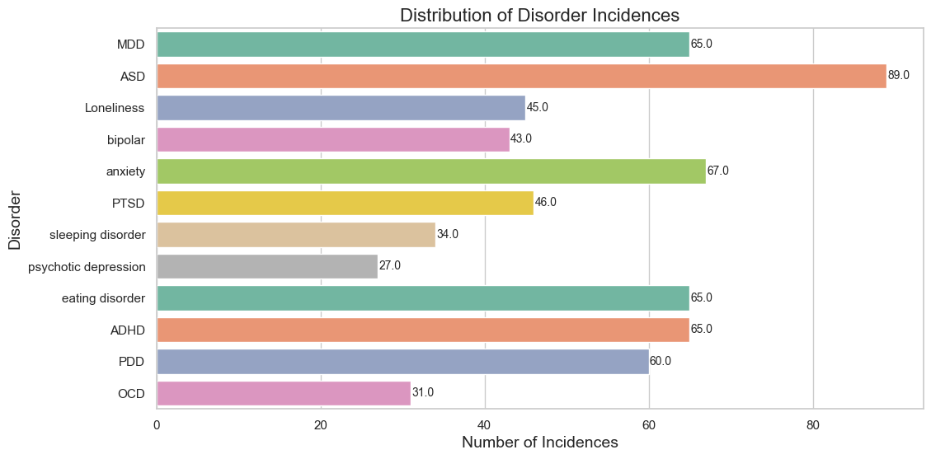

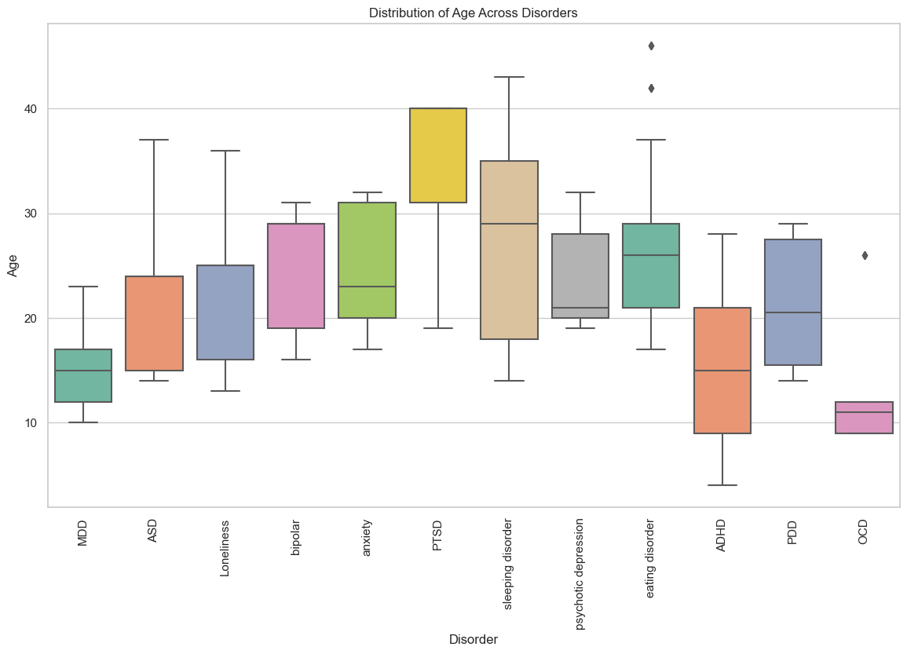

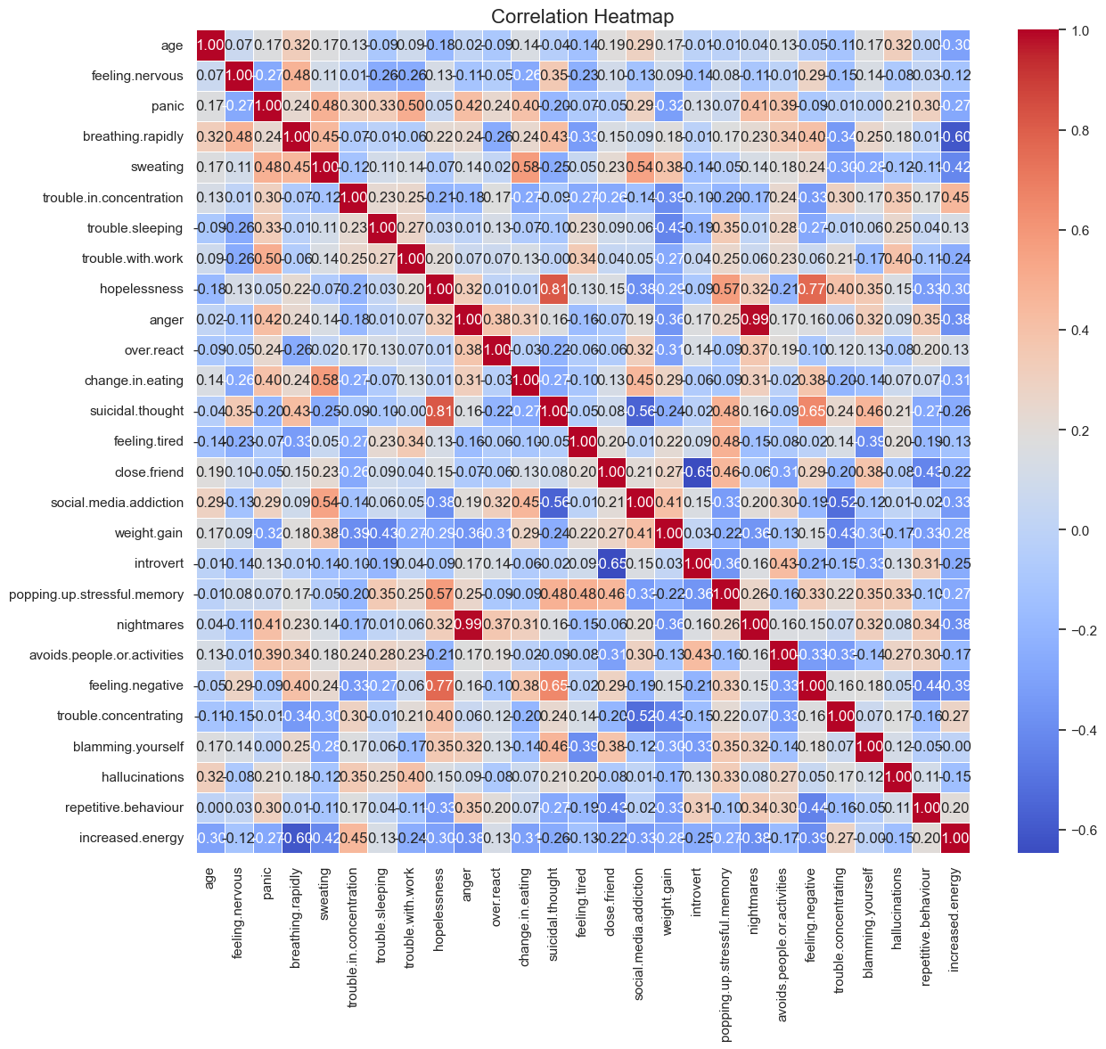
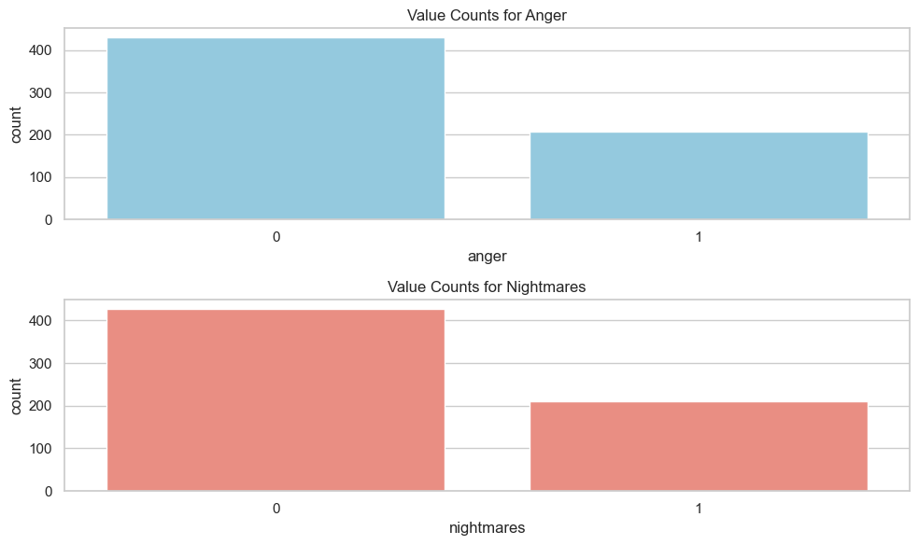

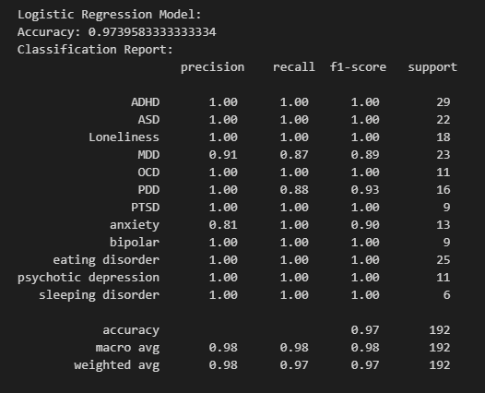

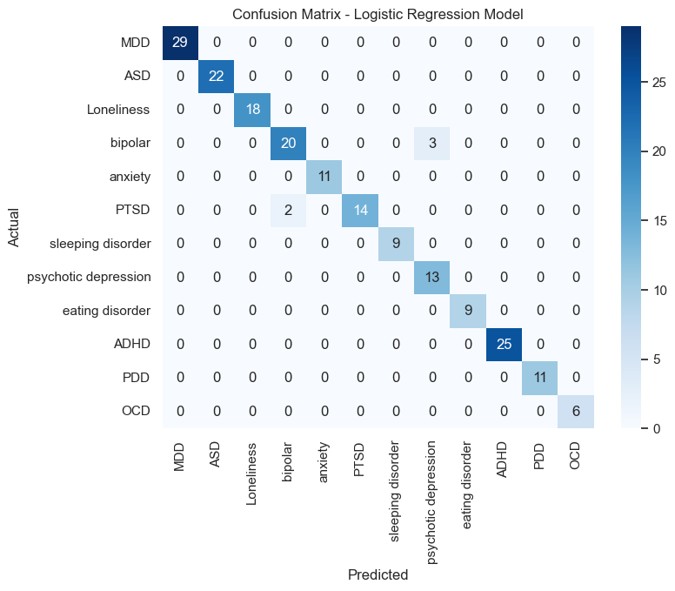

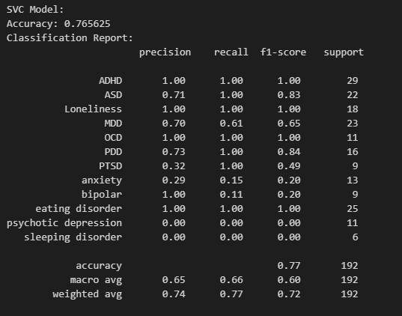

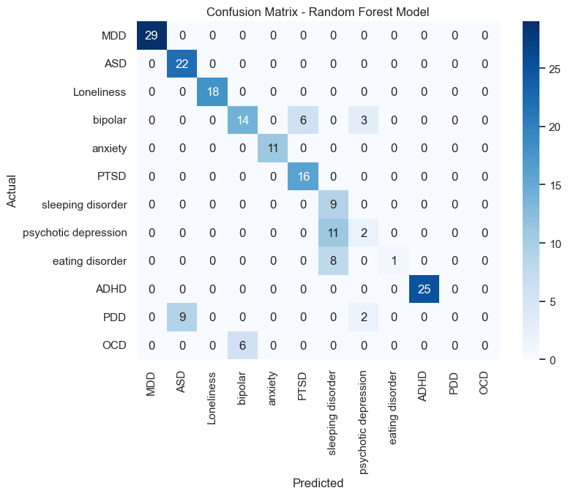

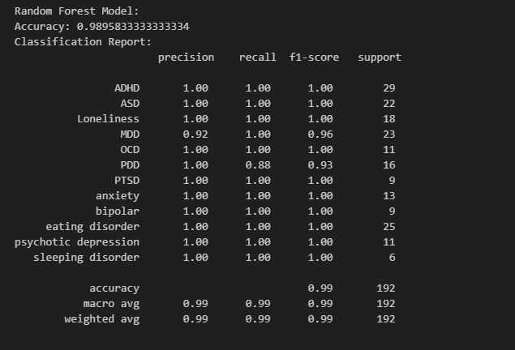

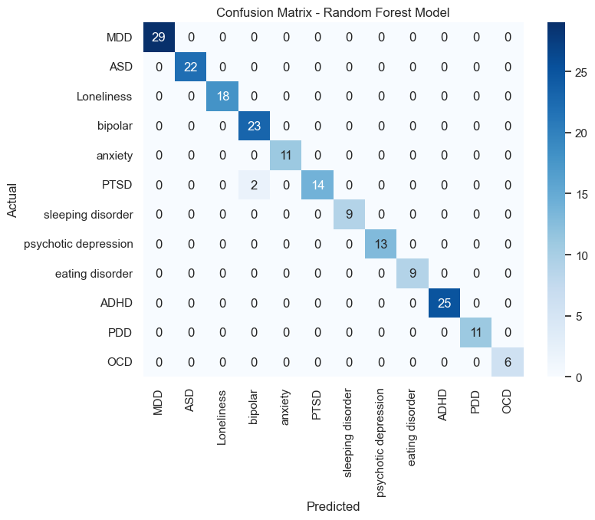
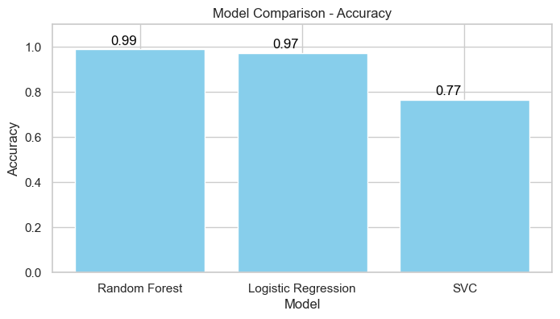

Coding

importnumpy as np
import pandas as pd
importseaborn as sns
importmatplotlib.pyplot as plt
fromsklearn.preprocessing import LabelEncoder
fromsklearn.model_selection import train_test_split
fromsklearn.tree import DecisionTreeClassifier
fromsklearn.ensemble import RandomForestClassifier
fromsklearn.linear_model import LogisticRegression
fromsklearn.metrics import accuracy_score, classification_report, confusion_matrix

health = pd.read_excel("Mental disorder symptoms.xlsx")
health.sample(3)
health.shape
health.info()
health.describe()
health.columns
health.isnull().sum()

health.rename(columns={'ag+1:629e': 'age'}, inplace=True)
health = health.rename(columns={'having.trouble.in.sleeping':'trouble.sleeping'})
health = health.rename(columns={'having.trouble.with.work':'trouble.with.work'})
health = health.rename(columns={'having.nightmares':'nightmares'})
health.sample(2)

health.drop(columns=['seasonally'], inplace=True)
sns.set(style="whitegrid")
plt.figure(figsize=(10, 6))
sns.histplot(health['age'], kde=True, bins=30, color='skyblue')
plt.title('Distribution of Ages in the Health DataFrame', fontsize=16)
plt.xlabel('Age', fontsize=14)
plt.ylabel('Frequency', fontsize=14)
plt.show()

Disorders = health.Disorder.unique()
Disorders
health['Disorder'].replace({'anexiety': 'anxiety', 'psychotic deprission': 'psychotic depression'}, inplace=True)
Disorders = health['Disorder'].unique()
print(Disorders)
# Sum the incidences of the various symptoms
symptom_incidences = health[health.columns[1:27]].sum()
# Plotting
plt.figure(figsize=(12, 6))
ax = symptom_incidences.sort_values(ascending=False).plot(kind='bar', color='skyblue')
# Add labels and a title
plt.title('Incidences of Various Mental Health Symptoms', fontsize=16)
plt.xlabel('Symptoms', fontsize=14)
plt.ylabel('Total Incidences', fontsize=14)

# Add data labels on top of each bar
for p in ax.patches:
ax.annotate(f'{p.get_height()}', (p.get_x() + p.get_width() / 2., p.get_height()), ha='center', va='center', xytext=(0, 10), textcoords='offset points', fontsize=10)

# Show the plot
plt.show()

incidences = health.Disorder.value_counts()
plt.figure(figsize=(12, 6))
ax = sns.countplot(y='Disorder', data=health, palette='Set2')
plt.title('Distribution of Disorder Incidences', fontsize=16)
plt.xlabel('Number of Incidences', fontsize=14)
plt.ylabel('Disorder', fontsize=14)

for p in ax.patches:
ax.annotate(f'{p.get_width()}', (p.get_width() + 0.1, p.get_y() + p.get_height() / 2.), ha='left', va='center', fontsize=10)
plt.show()

plt.figure(figsize=(14, 8))
sns.boxplot(x='Disorder', y='age', data=health, palette='Set2')
plt.title('Distribution of Age Across Disorders')
plt.xlabel('Disorder')
plt.ylabel('Age')
plt.xticks(rotation=90)
plt.show()

correlation_matrix = health.corr()
plt.figure(figsize=(14, 12))
sns.heatmap(correlation_matrix, annot=True, cmap='coolwarm', fmt='.2f', linewidths=.5)
plt.title('Correlation Heatmap', fontsize=16)
plt.show()

plt.figure(figsize=(10, 8))
sns.scatterplot(x='anger', y='nightmares', data=health, color='skyblue')
plt.title('Scatterplot of Anger and Nightmares', fontsize=16)
plt.xlabel('Anger', fontsize=14)
plt.ylabel('Nightmares', fontsize=14)
plt.show()

anger_counts = health['anger'].value_counts()
nightmares_counts = health['nightmares'].value_counts()
print("Value Counts for 'anger' column:")
print(anger_counts)
print("\nValue Counts for 'nightmares' column:")
print(nightmares_counts)
plt.figure(figsize=(10, 6))

# Plot the value counts for 'anger'
plt.subplot(2, 1, 1)
sns.countplot(x='anger', data=health, color='skyblue')
plt.title('Value Counts for Anger')

# Plot the value counts for 'nightmares'
plt.subplot(2, 1, 2)
sns.countplot(x='nightmares', data=health, color='salmon')
plt.title('Value Counts for Nightmares')
plt.tight_layout()
plt.show()

fromsklearn.feature_selection import RFE
X = health.drop('Disorder',axis=1)
y = health['Disorder']
# Perform Recursive Feature Elimination (RFE) with Logistic Regression
logreg = LogisticRegression(random_state=42)
rfe = RFE(logreg, n_features_to_select=10)
X_rfe = rfe.fit_transform(X, y)

# Display the selected features
selected_features = X.columns[rfe.support_]
print("Selected Features:", selected_features)
meaningful_names = {
'sweating': 'Sweating',
'trouble.in.concentration': 'Trouble in Concentration',
'trouble.sleeping': 'Trouble Sleeping',
'close.friend': 'Close Friend',
'introvert': 'Introvert',
'popping.up.stressful.memory': 'Stressful Memory',
'avoids.people.or.activities': 'Avoids People or Activities',
'feeling.negative': 'Feeling Negative',
'blamming.yourself': 'Blaming Yourself',
'increased.energy': 'Increased Energy',
}
selected_features = ['sweating', 'trouble.in.concentration', 'trouble.sleeping', 'close.friend', 'introvert',
'popping.up.stressful.memory', 'avoids.people.or.activities', 'feeling.negative',
'blamming.yourself', 'increased.energy']
selected_features_meaningful = [meaningful_names.get(feature, feature) for feature in selected_features]
print("Selected Features (Meaningful Names):", selected_features_meaningful)

X = health[selected_features]
y = health['Disorder']

# Split the dataset into training and testing sets (80% training, 20% testing)
X_train, X_test, y_train, y_test = train_test_split(X, y, test_size=0.3, random_state=42)

# Logistic Regression model
lr_model = LogisticRegression(random_state=42)
lr_model.fit(X_train, y_train)
lr_predictions = lr_model.predict(X_test)

print("\nLogistic Regression Model:")
print("Accuracy:", accuracy_score(y_test, lr_predictions))
print("Confusion Matrix:\n", confusion_matrix(y_test, lr_predictions))
print("Classification Report:\n", classification_report(y_test, lr_predictions))

fromsklearn.svm import SVC
svc_model = SVC(kernel='sigmoid', C= 0.5, gamma= 0.5)
svc_model.fit(X_train, y_train)
# Make predictions on the test set
svc_predictions = svc_model.predict(X_test)

# Evaluate the SVC model
print("SVC Model:")
print("Accuracy:", accuracy_score(y_test, svc_predictions))
print("Confusion Matrix:\n", confusion_matrix(y_test, svc_predictions))
print("Classification Report:\n", classification_report(y_test, svc_predictions))
# Store the model names
model_names = ['Logistic Regression', 'SVC']

# Store the accuracy scores for each model
accuracy_scores = [
accuracy_score(y_test, lr_predictions),
accuracy_score(y_test, svc_predictions)]

# Store the classification reports for each model
classification_reports = [
classification_report(y_test, rf_predictions, output_dict=True),
classification_report(y_test, lr_predictions, output_dict=True),
classification_report(y_test, svc_predictions, output_dict=True)]

# Create a DataFrame for model comparison
model_comparison_df = pd.DataFrame({
'Model': model_names,
'Accuracy': accuracy_scores,
'Precision (weighted avg)': [report['weighted avg']['precision'] for report in classification_reports],
'Recall (weighted avg)': [report['weighted avg']['recall'] for report in classification_reports],
'F1 Score (weighted avg)': [report['weighted avg']['f1-score'] for report in classification_reports]
})
# Display the model comparison DataFrame
print("Model Comparison:")
print(model_comparison_df)
# Plot a bar chart for accuracy comparison with data labels
plt.figure(figsize=(10, 6))
bars = plt.bar(model_comparison_df['Model'], model_comparison_df['Accuracy'], color='skyblue')
plt.title('Model Comparison - Accuracy')
plt.xlabel('Model')
plt.ylabel('Accuracy')
plt.ylim([0, 1.1])
# Add data labels to the bars
for bar, accuracy in zip(bars, model_comparison_df['Accuracy']):
plt.text(bar.get_x() + bar.get_width() / 2 - 0.1, bar.get_height() + 0.02, f'{accuracy:.2f}', ha='center', color='black')
plt.show()
new_data_dict = {
'sweating': 0,
'trouble.in.concentration': 1,
'trouble.sleeping': 1,
'close.friend': 0,
'introvert': 1,
'popping.up.stressful.memory': 1,
'avoids.people.or.activities': 1,
'feeling.negative': 1,
'blamming.yourself': 0,
'increased.energy': 0
}

# Create a DataFrame with a single row containing the new data
new_data = pd.DataFrame([new_data_dict])

# Display the new data
print("New Data:")
print(new_data)

